BioLink Morphology
BioLink Morphology 2
The Morphology Explorer 2
Creating New Projects 2
Project Groups 3
Matrix Project Details 3
The Characters tab 3
The Entities tab 4
The Views tab 5
The Multimedia tab 5
The References tab 6
User-Defined Traits tab 7
User-Defined Notes tab 7
The Character Explorer 8
Adding New Characters 8
Renaming and Deleting Characters 8
Character Groups 8
Character Details 8
The General tab 9
The Alternate Text tab 9
The Dependencies tab 10
The Multimedia tab 10
The References tab 11
User-Defined Traits tab 12
User-Defined Notes tab 12
Character State Details 13
Locating Characters and States: the Find tab 13
Managing commonly used characters and sets of characters: the Favorites tab 13
Transferring characters to Favorites 14
Organising Favorites using Favorites Groups 14
Removing items and groups from Favorites 14
The View Explorer 14
Adding, Renaming and Removing Views 14
View Groups 14
View Details 15
The Matrix 15
Launching the Matrix 15
The Matrix Window 15
Adding New Characters to the Matrix 16
Adding New Characters 16
Selecting Existing Characters 16
Adding New States to a Character 16
Adding New Entities to the Matrix 17
Adding New Entities 17
Selecting Existing Entities 17
Coding Descriptions using the Matrix 17
Ordered and Unordered Multistate Characters 17
Count and Measurement Numeric Characters 17
Mixed Numeric Characters 18
Text Characters 18
Using Default States 18
Inheritance and Compilation 18
Views 19
Changing the Phrases and Language used by Views 19
Coding Information Using a Different View 19
User-defined Traits and Resources 19
Finding and Filtering Information 19
Finding Information in the Matrix 20
Using Filters 20
Changing the Look of the Matrix 20
Text-based Descriptions and Diagnoses 21
Descriptions 21
Diagnoses 21
Interactive Identifications 21
The Key Builder 23
Creating a Dichotomous Key Project 23
How Dichotomous Keys Work 23
Problems with Paper-based Keys 24
Building a Key with the Key Builder 24
Importing and Exporting Data 24
Importing Data 24
Exporting Data 25

BioLink Morphology
BioLink Morphology provides tools for describing taxa (and optionally individual specimens) using a range of morphological character types. This is information can then be used for developing diagnoses, text-based descriptions and identification guides as well as feeding into phylogenetic studies. BioLink Morphology, combined with the richness and flexibility provided by other BioLink modules, supports essentially all of the information needed for modern specimen-based systematics research.
BioLink Morphology uses Projects to hold sets of characters, taxa and (optionally) specimens. These sets are drawn from the global list of taxa and characters held by a BioLink database. A given taxon can be used in any number of projects and with any set of characters and a given character can be used in multiple projects and with any number of taxa.
The centre pieces of Morphology are the Matrix, Interactive Identification and Key Builder windows. These support data entry and exploration, interacting directly with “live” data (rather than a copy of data as other packages do). In addition, a series of tools support global searches across entire projects, filtering to locate subsets of taxa, the development of multiple diagnostic characters lists and text-based descriptions which are tied directly to the data entry Matrix window. These tools combine to provide a rich environment for developing high quality morphology-based descriptions for projects both small and large.

The Morphology Explorer
Projects are used to assemble characters and taxa into sets ready for data coding. These projects are created and managed using the Morphology Explorer. To open the Explorer click the Morphology button on the main BioLink toolbar or open this button by clicking on the arrow to the right of the button and select the Morphology Explorer command.
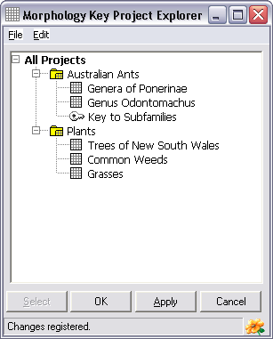
BioLink supports two types of projects, Matrix and Key. Matrix projects (represented by a ‘grid’ icon) are used to create diagnoses, text-based descriptions and interactive identifications while Key projects (represented by a ‘key’ icon) are used to constrict dichotomous keys. Both support images and multimedia and can export to a range of formats.

Creating New Projects
To create a new Matrix project select the Matrix Project command under Add on the Explorer’s Edit menu. Now enter a name for this project and press the Enter key. To create a Key project select the Dichotomous Key Project command from this same menu. Enter a name for this project and press Enter. Finally, press the Explorer’s OK or Apply button to save the project.

Project Groups
Projects can be organized into Groups within the Morphology Explorer. Groups are used to organize related sets of projects, for example by grouping Matrix and Key projects together. To create a new group, first highlight the All Projects item within the Explorer and then select the Project Group command under Add on the Explorer’s Edit menu. Enter a name for this new group and press the Enter key. Existing projects can be moved into a group using Drag and Drop and new projects can be created within an existing Group by first highlighting the Group and then creating the new project.

Matrix Project Details
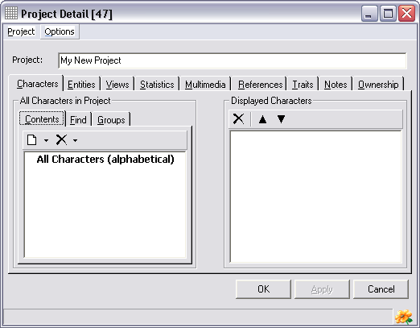
Matrix projects contain a range of information about the project. This information is entered using the Project Detail window. To open this window select a Matrix project followed by the Edit command from the Edit menu. The following information can be recorded.
Characters: A list of the characters used by the project.
Entities: A list of the taxa and specimens used by the project.
Views: Sets of alternative phrasings for characters (see Views below for details).
Statistics: Assorted statistics concerning the project.
Multimedia: Images, sounds, movies and other digital-based information associated with the project.
References: Literature references used by the project.
Traits: User-defined attributes for the project.
Notes: Text-based information relating to the project.
This information is entered using the following tabs on the Project Details window.

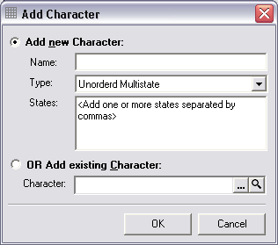
The Characters tab
This tab contains a list of all characters currently available within the project. This is required as the global character list, the list of all characters within a database and managed using the Character Explorer (see below), may be quite large and only a subset of these will be relevant to any given project or set of taxa.
Adding New Characters to a Project
To add a new character to a project click the New toolbar button in the All Characters in Project group. This will open the Add Character window. Enter the character description in the upper text box, select the type of character from the list and enter states (for multistate and mixed numeric characters) in the lower text box, with individual states separated by commas. Once entered press the OK button to save this character. Continue adding characters and press the Project Detail window’s OK or Apply buttons to save these changes when finished.
The following types of characters are supported.
Unordered Multistate: Characters which contain two or more distinct states and where there is no relationship among the states.
Ordered Multistate: Characters which contain two or more distinct states and where there is a linear relationship or order among the states.
Count Numeric: An integer-based numeric character.
Measurement Numeric: A real or decimal-based numeric character.
Mixed Numeric: A numeric character containing several distinct and separate values (for example maximum and minimum values or a mean and standard deviation).
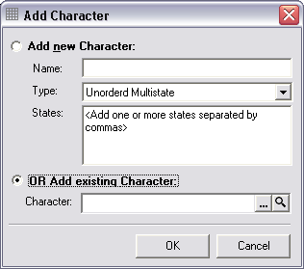
Text: A text-based character.

Selecting Existing Characters
Previously entered characters can be accessed by selecting the Add existing Character option from the lower section of the Add Character window and pressing the Character field’s ellipsis button (the first button to the right of the field). This will open the Character Explorer (see below) with a complete list of characters present in the database. The required character can then be located and the Select button used to transfer it to the Project Details window.
Removing and Deleting Characters
Characters can be removed from a project (while remaining in the database) or deleted from both the project and the database. To remove a character from the project select it, click the Remove toolbar button (the one on the right) or click the right mouse button and select the Remove command. To delete a character permanently from the database, first select it then click the arrow to the right of the Remove toolbar button (the one on the right) and select the Delete from Database command.
Displayed Characters
All characters present in a project will be listed on the left side of the Characters tab. The list on the right of the tab contains the characters that will be displayed when entering information using the Matrix (see below). This second list also controls the order characters are displayed, with those at the top of the list being displayed before those lower in the list. By default, all characters are displayed and are added to the beginning of the list. To hide a character select it and press the Hide Character toolbar button (the first on the left), or click the right mouse button and select the Hide Selected Characters command, or press the Delete key. To redisplay a character select it in the left list, click the right mouse button and select the Display command.

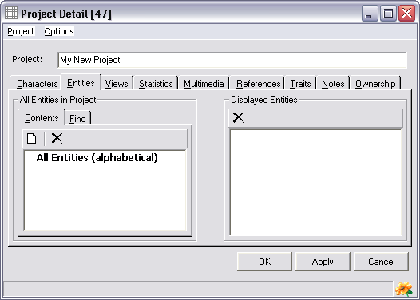
The Entities tab
Entities are taxa or specimens which are to be coded for the characters entered using the Characters tab.
Adding New Entities
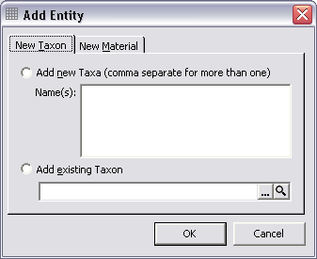
To add a new entity press the New toolbar button (the first button on the left) in the All Entities in Project group. This will open the Add Entity window. To enter a taxon, click the New Taxon tab and to enter new material click the New Material tab. Any number of entities can be entered by listing them in the upper text box separated by commas. When all entities have been entered press the OK button to save this information.
Selecting Existing Taxa
If taxa or specimens were previously entered in BioLink (for example using the Taxon Explorer or Material Rapid Data Entry) they can be accessed by selecting the Add existing Taxon or Add existing Material option on the Add Entity window and pressing the ellipsis button (the first button to the right of the field). This will open the either the Taxon Explorer or Site Explorer where the required taxon or specimen can be located. Once selected, press the Explorer’s Select button to transfer the item to the Add Entity window.
Removing Entities
An entity can be removed from a project (while remaining in the database) by first select it then clicking the Remove toolbar button (the one on the right) or by clicking the right mouse button and selecting the Remove command.
Displayed Entities
All entities present in a project will be listed on the left side of the Entities tab. The list on the right of the tab contains the entities that will be displayed when entering information using the Matrix (see below). This second list also controls the order entities are displayed, with those at the top of the list being displayed before those lower in the list. By default, all entities are displayed and are added to the beginning of the list. To hide an entity select it and press the Hide Entity toolbar button, or click the right mouse button and select the Hide Selected Entities command, or press the Delete key. To redisplay an entity select it in the left list, click the right mouse button and select the Display command.

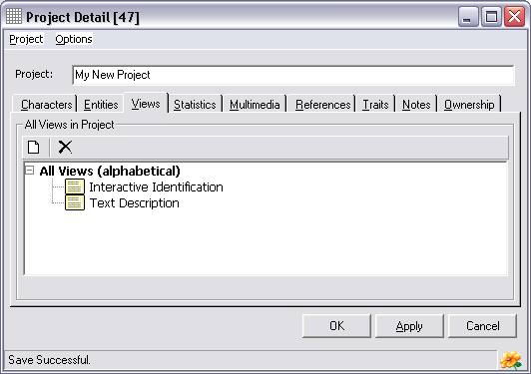
The Views tab
Views are used to develop alternate phrasings and language for characters and descriptions. For example, the most appropriate phrasing for text-based descriptions may differ slightly from that used for interactive identifications. Another common example is the need to support multiple languages such as Spanish and German. BioLink uses Views to manage these alternative representations of essentially the same information, with any number of Views supported for each character and description. For details of how to enter information related to Views see The Matrix and The Character Explorer below.
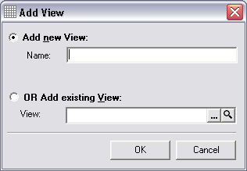
Adding Views
To add a View to a project first open the View tab and then click the Create New View toolbar button (the one on the left). This will open the Add View window. To create a new View enter its name in the upper box. To use an existing View click the ellipsis box on the right side of the lower text box. This will open the View Explorer. Locate the required View and press the Explorer’s Select button (for further details about this explorer see The View Explorer below). Once this information has been entered press the OK button on the Add View window. This will add the View to the Project Detail window.
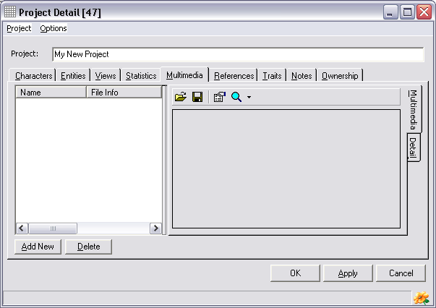
Renaming and Removing Views
To rename a View or to remove it from the project, select the required View in the list, click the right mouse button and select either the Rename or Remove from Project commands.

The Multimedia tab
It is often necessary to associate electronically stored or file-based information with a project. BioLink terms this electronic (or digital) information ‘multimedia’. Multimedia can consist of image, sound or video files as well as text documents, spreadsheets or even databases. Any number of multimedia files can be stored for a project. In addition to the actual file, its type, name and caption can also be stored. These files are stored within the BioLink database rather than as links to local files found outside of BioLink. This ensures that this information is always present and reduces the chance of accidental deletion.
To add a new multimedia item, press the Add New button near the lower left corner of the window. This will create a new entry in the list on the left side of the window and open a File Open dialog box. Locate the file to be added and press OK. This will add the file to BioLink. Alternately, a file can be moved from the Windows Explorer or My Computer using Drag and Drop. Locate the desired file in the Windows Explorer or using My Computer and drag it onto either the Multimedia list or the preview window (on the lower right of the Multimedia window). Details for the file can be entered in the fields on the Detail tab. To edit information for a previously entered file, select it in the list and edit its details on the right. To delete a file select it and press the Delete button. Once changes have been made, press the OK button to save changes and close the project window or the Apply button to save changes and leave the window open. Pressing the Cancel button will close the window without saving changes.
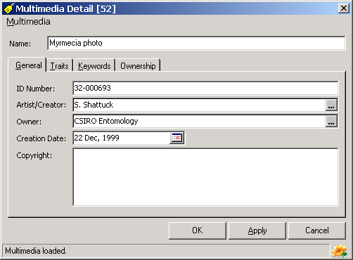
The Preview window, on the Multimedia tab, will display a preview of most graphics files. If the selected file cannot be viewed, a message will be displayed. To view these non-displayable files, press the magnifying glass button on the toolbar. This will open the application associated with the file and automatically load the file. If no application is associated with the selected file a dialog will open asking the name of the application to use to view the file.
To replace an existing file with a new one, select the old file in the list and press the first toolbar button (the button with the file folder icon). A File Open dialog box will be displayed allowing selection of the replacement file. To save an existing file to disk, select it in the list and press the second toolbar button (the button with a disk icon). A Save As dialog box will open where a new file name and path can be entered. To view properties of a given file press the third toolbar button (with the properties icon). This will open a window where details on an identification number, artist/creator, owner, creation date, copyright, traits and keywords can be entered.

The References tab
Any number of references can be associated with a project. The type of each reference can be specified along with page number(s) and comments about the reference. By specifying a type, references can be grouped into sets of related references.
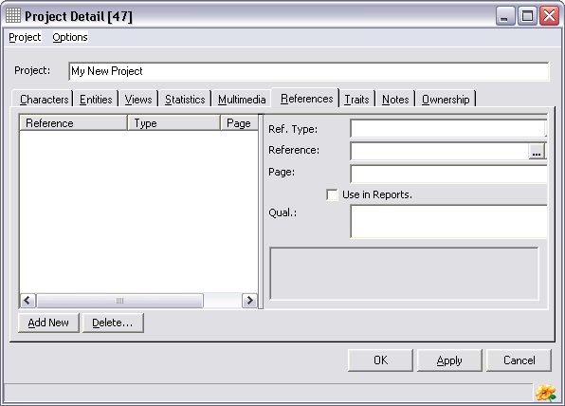
To add a new reference, press the Add New button near the lower left corner of the window. This will add a new entry to the list of references on the left side of the window. Enter the appropriate information to the fields on the right side of the window as outlined below. To edit a previously entered reference select it in the list and edit its details on the right. To delete a previously entered reference select it in the list and press the Delete key. Once changes have been made press the OK button to save changes and close the project window or the Apply button to save changes and leave the window open. Pressing the Cancel button will close the window without saving changes.
The following items concerning references can be stored.
Reference Type: An indication of the type of this reference. This is used to group related references and as an indication of the nature of the reference. Specific types are user-defined and will commonly include such things as morphology, taxonomy or identification.
Reference: The Reference Code for the reference concerning this project. To select a reference, press the ellipsis button (with the three dots) to the right of the field to open the Reference Manager. Locate the required reference and press the Reference Manager’s Select button. This will transfer the Reference Code to the References tab. Alternately the Reference Code can be typed directly in the field. To see details of the selected reference press the Magnifying Glass button to the right of the Reference field. This will open the Reference Details window containing the selected reference.
Page: The page number within the reference relating to the project.
Use In Reports: This option is used in combination with the Report Writer. It can be used to restrict the reporting of references only to those where Use In Reports has be selected.
Qualification: Notes concerning the reference.

User-Defined Traits tab
BioLink supports information that is common across most taxonomic groups and scientific disciplines. However, specific taxa and disciplines will need to manage additional information not directly supported by BioLink. This information includes such things as observation methods and attributes of characters. The list of these sorts of data elements is almost limitless.
To address this problem, BioLink supports Traits and Notes. Traits are used to store information about items that are not found in other BioLink windows. They allow the storage and reporting of a wide range of items that are project specific, or that are required for a specific report but are not generally required for most activities. In essence, Traits allow the addition of new fields when and where required.
To add a new Trait press the Add New button near the lower left corner of the window. This will open a window with a list of previously used Trait types. Select an existing Trait from the list or create a new one using the Add New button near the bottom of the list. Press the OK button on the Trait window to create the new Trait and copy it to the Taxon Details window. The value for this new Trait can then be entered in the Trait Value field on the right side of the Traits tab. A comment concerning this Trait can also be included. To delete a Trait, select it in the list and press the Delete button. Once changes have been made press the OK button to save changes and close the project window or the Apply button to save changes and leave the window open. Pressing the Cancel button will close the window without saving changes.

User-Defined Notes tab
Notes are essentially the same as Traits except they are used to store text-based information. They can be of any length, can contain font and paragraph formatting (such as bold, italics, underlining, font type, size and colour, justification and hanging indents) and any number of Notes can be created for a project. Notes can also contain embedded graphics.
To add a new Note press the Add New button near the lower left corner of the window. This will open a window with a list of previously used Note types. Select an existing Note or create a new one using the Add New button near the bottom of the list. Press the OK button on the Note window to create the new Note and copy it to the taxon window. The text for this new Note can then be entered in the right side of the Notes tab. To format text, including bold, italics, underlining, font size and font colour, select the text and use the buttons on the toolbar. Symbols can be entered by pressing the sigma button. The Note text can be printed and copied or cut to the clipboard using toolbar buttons, and the contents of the Clipboard can be added to a Note using the Paste button.
Once changes have been made press the OK button to save changes and close the project window or the Apply button to save changes and leave the window open. Pressing the Cancel button will close the window without saving changes.

The Character Explorer
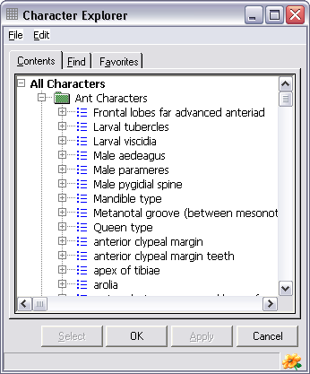
The Character Explorer lists all characters currently in a database. Characters can be added and deleted using this Explorer, and their properties modified.

Adding New Characters
To add a new character to the Explorer select the Character command under Add on the Edit menu. This will open the Add Character window. Enter the character description in the upper text box, select the type of character from the drop-down list and enter states (for multistate and mixed numeric characters) in the lower text box, with individual states separated by commas. Once entered press the OK button to save this character. Continue adding characters and press the Explorer’s OK or Apply buttons to save these changes when finished.
The following types of characters are supported.
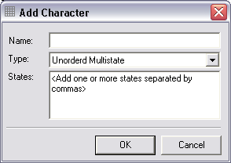
Unordered Multistate: Characters which contain two or more distinct states and where there is no relationship among the states.
Ordered Multistate: Characters which contain two or more distinct states and where there is a linear relationship or order among the states.
Count Numeric: An integer-based numeric character.
Measurement Numeric: A real or decimal-based numeric character.
Mixed Numeric: A numeric character containing several distinct and separate values (for example maximum and minimum values or a mean and standard deviation).
Text: A text-based character.

To add new states to a multistate or mixed numeric character, highlight the character to which the state is to be added and select the Character State command under Add on the Edit menu. Enter the name of the state and press Enter. Once complete, press the OK or Apply button to save these changes.

Renaming and Deleting Characters
Characters (and character states) can be deleted from the database (and all projects using this character) by first highlighting it and then selecting the Delete command from the Edit menu. To rename a character select the Rename command from Edit menu. Modify the name as required and press Enter.

Character Groups
Characters can be organized into Groups within the Character Explorer. Groups are used to organize related sets of characters, for example by morphological structure or those relating to a specific taxonomic group. To create a new group, first highlight the All Characters item within the Explorer and then select the Character Group command under Add on the Explorer’s Edit menu. Enter a name for this new group and press the Enter key. Existing characters can be moved into a group using Drag and Drop and new characters can be created within an existing Group by first highlighting the Group and then creating the new character.

Character Details
A range of information can be stored for each character. This information is accessed through the Character Detail window. To open this window highlight a character in the Character Explorer and select the Edit command from the Edit menu. The following information can be recorded.
General: A list of states for multistate and mixed numeric characters and bounding values for numeric characters.
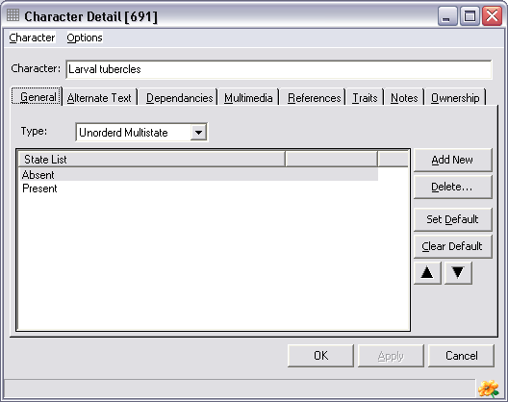
Alternate Text: The text used by Views of the character.
Dependencies: Documents relationships among characters.
Multimedia: Images, sounds, movies and other digital-based information associated with the project.
References: Literature references used by the project.
Traits: User-defined attributes for the project.
Notes: Text-based information relating to the project.
This information is entered using the following tabs on the Character Details window.

The General tab
This tab contains a list of states for multistate and mixed numeric characters and the minimum value, maximum value and units for count and measurement numerics.
The following types of characters are supported.
Unordered Multistate: Characters which contain two or more distinct states and where there is no relationship among the states.
Ordered Multistate: Characters which contain two or more distinct states and where there is a linear relationship or order among the states.
Count Numeric: An integer-based numeric character.
Measurement Numeric: A real or decimal-based numeric character.
Mixed Numeric: A numeric character containing several distinct and separate values (for example maximum and minimum values or a mean and standard deviation).
Text: A text-based character.

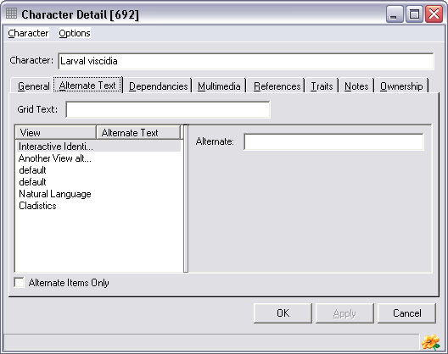
The type of the character can be set by selecting the appropriate entry in the drop-down list. Once selected additional information can be entered (as appropriate) in the lower section of the tab using the buttons on the right and entering text on the left. For example, to add a new state press the Add New button and enter the text of the state in list on the left. To delete a state highlight it and press the Delete button. To set a default state highlight it and press the Set Default button while pressing the Clear Default button will clear a previously set default. The order of states can be changed by highlighting a state and using the up arrow and down arrow buttons.

The Alternate Text tab
Alternate text is used by Views when displaying characters and descriptions. This allows the exact phrasing and language of characters to be customized for specific projects or reports. For example, the most appropriate phrasing for text-based descriptions may differ slightly from that used for interactive identifications. Another common example is the need to support multiple languages such as Spanish and German. Views are used to manage these alternative representations of essentially the same information.
To add a new phrase or language for a character highlight a view on the left and enter its new description in the Alternate text box on the right.
To list only those views for which alternate text has been entered check the Alternate Items Only checkbox on the bottom left of the window.
To change the phrasing of the character used by the Matrix enter the new name in the Matrix Text box along the top of the tab. This can be a short abbreviation for the character that will be display in limited space available within the Matrix.

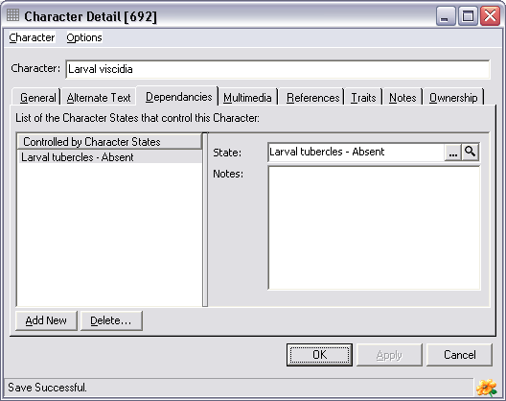
The Dependencies tab
Dependencies are used to build relationships among characters. These relationships are used to effectively “turn off” or disable a character based on another character. For example, characters relating to wings should be disabled when wings are absent. Dependencies are used to specify the “controlled character” and its “controlling states”.
To enter a character state to disable the current character first click the Add New button on the bottom-left of the tab. This will add a entry in the list on the left side of the tab. Now open the Character Explorer and locate the character and its state that, when coded in the Matrix, will disable this character. Drag the appropriate state and drop it onto State text box on the Dependencies tab. Alternately, use the ellipsis button to the right of the States text box to open the Character Explorer, locate the required state and press the Explorer’s Select button to transfer the state to the Character Detail window (note that the Select button will only work if the Explorer is opened using the Ellipsis button and not if the Explorer is opened directly). To delete a dependency highlight it in the list on the left and press the Delete button. Notes about a dependency can be added to the Notes field on the right side of the tab.

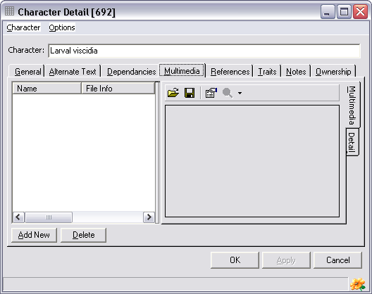
The Multimedia tab
It is often necessary to associate electronically stored or file-based information with a character. BioLink terms this electronic (or digital) information ‘multimedia’. Multimedia can consist of image, sound or video files as well as text documents, spreadsheets or even databases. Any number of multimedia files can be stored for a character. In addition to the actual file, its type, name and caption can also be stored. These files are stored within the BioLink database rather than as links to local files found outside of BioLink. This ensures that this information is always present and reduces the chance of accidental deletion.
To add a new multimedia item, press the Add New button near the lower left corner of the window. This will create a new entry in the list on the left side of the window and open a File Open dialog box. Locate the file to be added and press OK. This will add the file to BioLink. Alternately, a file can be moved from the Windows Explorer or My Computer using Drag and Drop. Locate the desired file in the Windows Explorer or using My Computer and drag it onto either the Multimedia list or the preview window (on the lower right of the Multimedia window). Details for the file can be entered in the fields on the Detail tab. To edit information for a previously entered file, select it in the list and edit its details on the right. To delete a file select it and press the Delete button. Once changes have been made, press the OK button to save changes and close the project window or the Apply button to save changes and leave the window open. Pressing the Cancel button will close the window without saving changes.
The Preview window, on the Multimedia tab, will display a preview of most graphics files. If the selected file cannot be viewed, a message will be displayed. To view these non-displayable files, press the magnifying glass button on the toolbar. This will open the application associated with the file and automatically load the file. If no application is associated with the selected file a dialog will open asking the name of the application to use to view the file.
To replace an existing file with a new one, select the old file in the list and press the first toolbar button (the button with the file folder icon). A File Open dialog box will be displayed allowing selection of the replacement file. To save an existing file to disk, select it in the list and press the second toolbar button (the button with a disk icon). A Save As dialog box will open where a new file name and path can be entered. To view properties of a given file press the third toolbar button (with the properties icon). This will open a window where details on an identification number, artist/creator, owner, creation date, copyright, traits and keywords can be entered.

The References tab
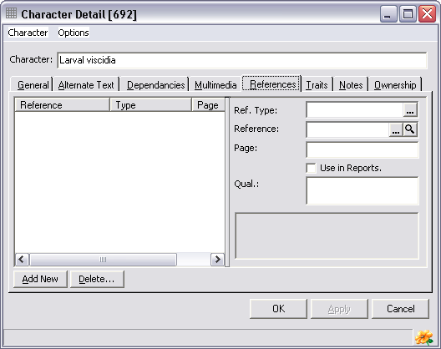
Any number of references can be associated with a character. The type of each reference can be specified along with page number(s) and comments about the reference. By specifying a type, references can be grouped into sets of related references.
To add a new reference, press the Add New button near the lower left corner of the window. This will add a new entry to the list of references on the left side of the window. Enter the appropriate information to the fields on the right side of the window as outlined below. To edit a previously entered reference select it in the list and edit its details on the right. To delete a previously entered reference select it in the list and press the Delete key. Once changes have been made press the OK button to save changes and close the project window or the Apply button to save changes and leave the window open. Pressing the Cancel button will close the window without saving changes.
The following items concerning references can be stored.
Reference Type: An indication of the type of this reference. This is used to group related references and as an indication of the nature of the reference. Specific types are user-defined and will commonly include such things as morphology, taxonomy or identification.
Reference: The Reference Code for the reference concerning this project. To select a reference, press the ellipsis button (with the three dots) to the right of the field to open the Reference Manager. Locate the required reference and press the Reference Manager’s Select button. This will transfer the Reference Code to the References tab. Alternately the Reference Code can be typed directly in the field. To see details of the selected reference press the Magnifying Glass button to the right of the Reference field. This will open the Reference Details window containing the selected reference.
Page: The page number within the reference relating to the project.
Use In Reports: This option is used in combination with the Report Writer. It can be used to restrict the reporting of references only to those where Use In Reports has be selected.
Qualification: Notes concerning the reference.

User-Defined Traits tab
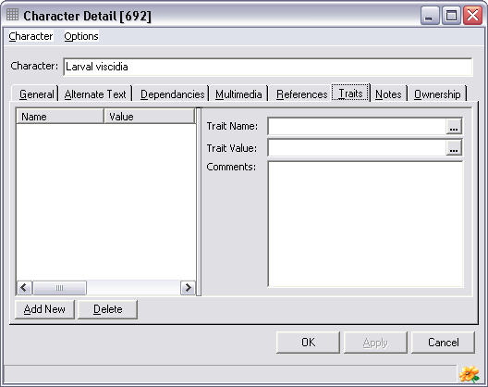
BioLink supports information that is common across most taxonomic groups and scientific disciplines. However, specific taxa and disciplines will need to manage additional information not directly supported by BioLink. This information includes such things as observation methods and attributes of characters. The list of these sorts of data elements is almost limitless.
To address this problem, BioLink supports Traits and Notes. Traits are used to store information about items that are not found in other BioLink windows. They allow the storage and reporting of a wide range of items that are project specific, or that are required for a specific report but are not generally required for most activities. In essence, Traits allow the addition of new fields when and where required.
To add a new Trait press the Add New button near the lower left corner of the window. This will open a window with a list of previously used Trait types. Select an existing Trait from the list or create a new one using the Add New button near the bottom of the list. Press the OK button on the Trait window to create the new Trait and copy it to the Taxon Details window. The value for this new Trait can then be entered in the Trait Value field on the right side of the Traits tab. A comment concerning this Trait can also be included. To delete a Trait, select it in the list and press the Delete button. Once changes have been made press the OK button to save changes and close the project window or the Apply button to save changes and leave the window open. Pressing the Cancel button will close the window without saving changes.

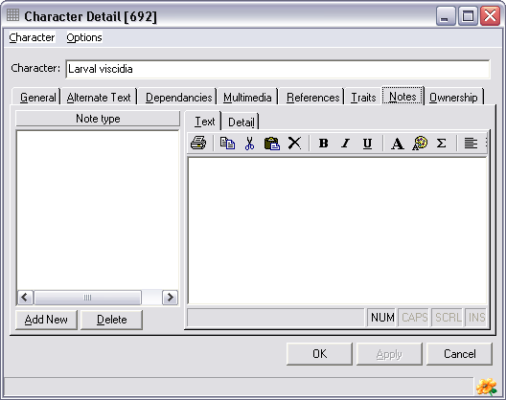
User-Defined Notes tab
Notes are essentially the same as Traits except they are used to store text-based information. They can be of any length, can contain font and paragraph formatting (such as bold, italics, underlining, font type, size and colour, justification and hanging indents) and any number of Notes can be created for a project. Notes can also contain embedded graphics.
To add a new Note press the Add New button near the lower left corner of the window. This will open a window with a list of previously used Note types. Select an existing Note or create a new one using the Add New button near the bottom of the list. Press the OK button on the Note window to create the new Note and copy it to the taxon window. The text for this new Note can then be entered in the right side of the Notes tab. To format text, including bold, italics, underlining, font size and font colour, select the text and use the buttons on the toolbar. Symbols can be entered by pressing the sigma button. The Note text can be printed and copied or cut to the clipboard using toolbar buttons, and the contents of the Clipboard can be added to a Note using the Paste button.
Once changes have been made press the OK button to save changes and close the project window or the Apply button to save changes and leave the window open. Pressing the Cancel button will close the window without saving changes.

Character State Details
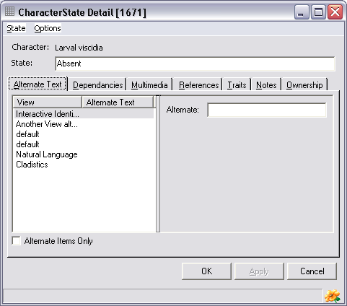
Character states are stored within the Character Explorer under each character (for multistate and mixed numeric characters) with range of information can be stored for each state. This information is accessed through the Character State Detail window. To open this window highlight a state in the Character Explorer and select the Edit command from the Edit menu. The following information can be recorded.
Alternate Text: The text used by Views of the character.
Dependencies: Documents relationships among characters.
Multimedia: Images, sounds, movies and other digital-based information associated with the project.
References: Literature references used by the project.
Traits: User-defined attributes for the project.
Notes: Text-based information relating to the project.
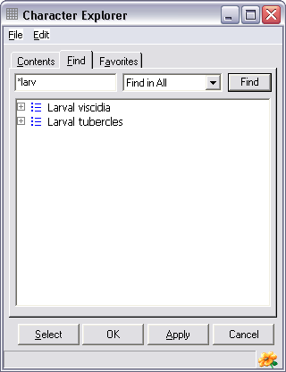
The details for these items are essentially the same as for Characters (as discussed above), the only exception being Dependencies. Instead of entering the state that disables a character, on the Character State Detail window the characters that are disabled by the selected state are entered. For example, if the character state “Wings absent” was currently selected, all characters used to describe wings would be entered on the Dependencies tab of this window. This would disable these characters when ever “Wings absent” was coded in the Matrix. Adding and managing this information is done as outlined above for character dependencies.

Locating Characters and States: the Find tab
The Find tab on the Explorer can be used to locate characters and states in the database. The drop-down list on the right can be used to select the kinds of items to be searched for. These include all items, characters, states and character groups.
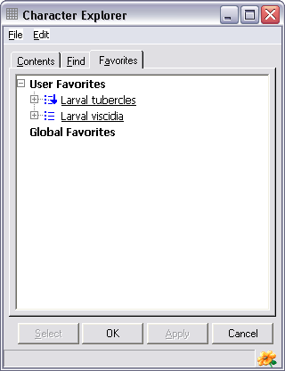
Enter a word or name in the upper box and press the Find button or the Enter key on the keyboard. A list of items matching the request will be displayed in the lower window. To find items containing a subset of characters, enter an asterisk wildcard (*) as the first character or between other characters (a wildcard is automatically added to the end of all requests). For example, to search for items containing ‘larv’, such as larvae or larval, enter ‘*larv’ in the Find box.
If an item located using Find contains states, these can be displayed by clicking on the plus symbol before its name (as is done on the Contents tab).

Managing commonly used characters and sets of characters: the Favorites tab
The Favorites tab can be used for easy access to commonly used characters. The use of Favorites can greatly simplify using the Character Explorer, particularly as the size and complexity of a database increases. Copying regularly used characters to Favorites will reduce the need to search for items and speed access to commonly used information.

Transferring characters to Favorites
Characters are transferred to Favorites from the Contents and Find tabs. To transfer an item, select it in Contents or Find and open the Edit menu or click the right mouse button. Select the Transfer Item to Favorites command followed by either the User Specific or Global command. Items transferred in this way will be displayed underlined in Favorites. This distinguishes these items from their children that were not directly transferred. User Specific favorites are only available to the user who was logged on when they were created, while Global favorites are available to all users of the database. Note that Favorites are copies of the items found on the Contents and Find tabs. Any changes made to Favorites, such as adding or deleting, will be saved to the database and will be seen by all users of these items. Thus, the same caution should be used when making changes to Favorites as these will have the same effect as making changes directly on the Contents tab.

Organising Favorites using Favorites Groups
While Favorites can simplify access to characters, its use can become less efficient as the number of items transferred to Favorites increases. To solve this potential problem, related characters can be grouped together in Favorite Groups. A Favorite Group can be thought of as a folder that contains a set of Favorites (and possibly other Favorite Groups).
To create a new Favorites Group, select the User Favorites item, Global Favorites item or an existing Favorite Group and click the right mouse button or open the Edit menu and select the Add Favorite Group command. Once created, items can be moved to the Group using drag and drop. Simply drag a character and drop it onto the Group it is to be placed within. Groups themselves can also be organised in a similar way.

Removing items and groups from Favorites
To remove an item from Favorites, select it and open the Edit menu or click the right mouse button and select the Remove Favorite command. A message will ask to confirm the removal. Note that removing an item from Favorites does not delete it from the database, it only removes it from Favorites and leaves it in Contents. Only items which were transferred directly to Favorites, those that are underlined, can be removed. Children of these Favorites cannot be removed and the Remove Favorite command will not be available if one of these is selected.
To permanently delete an item from Favorites as well as Content (and from the database) select the item, open the Edit menu or click the right mouse button and select the Delete command. A message will ask to confirm the delete. Once deleted, the item will be permanently removed from the database and cannot be retrieved (except from a backup copy of the database).

The View Explorer
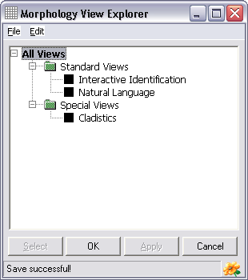
Views are used to develop alternate phrasings and language for characters and descriptions. For example, the most appropriate phrasing for text-based descriptions may differ slightly from that used for interactive identifications. Another common example is the need to support multiple languages such as Spanish and German. BioLink uses Views to manage these alternative representations of essentially the same information, and uses the Morphology View Explorer to manage Views.

Adding, Renaming and Removing Views
To add a View to the Explorer select the View command under Add on the Edit menu. Enter the name of this new view and press the Enter key. To rename or delete a View select the required View in the list, click the right mouse button or open the Edit menu and select either the Rename or Delete commands. If renaming a view, enter its new name and press Enter. Save any changes by pressing the Explorer’s OK or Apply button.

View Groups
Views can be organized into Groups within the View Explorer. Groups are used to organize related sets of views. To create a new group, first highlight the All Views item within the Explorer and then select the View Group command under Add on the Explorer’s Edit menu. Enter a name for this new group and press the Enter key. Existing views can be moved into a group using Drag and Drop and new views can be created within an existing Group by first highlighting the Group and then creating the new view as outlined above.

View Details
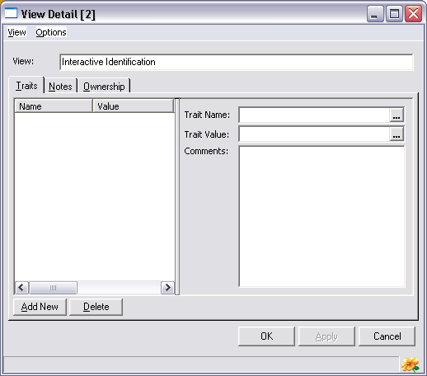
A range of information can be stored for each view. This information is accessed through the View Detail window. To open this window highlight a view in the View Explorer and select the Edit command from the Edit menu. The following information can be recorded.
Traits: User-defined attributes for the project.
Notes: Text-based information relating to the project.
For details on entering this information see above under Character Details.

The Matrix
The Matrix is used to code descriptions of taxa based on the characters in a project. It is where taxa and characters come together to produce text-based descriptions, dichotomous keys and interactive identification tools. The Matrix uses a range of tools to assist with collecting and maintaining this information. These tools are especially important as projects grow in complexity, allowing subsets of taxa to be selected and information located across entire projects. The Matrix is also highly integrated with other Morphology tools, most of these tools being able to be called from the Matrix. The Matrix is the centre-piece of BioLink Morphology and one of the most important and often-used modules.

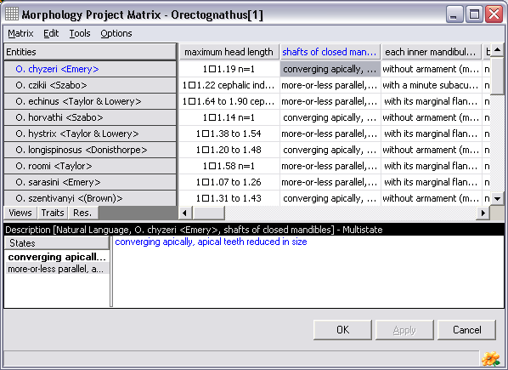
Launching the Matrix
The Matrix can be opened in two ways, either empty as when starting a new project or filled with data from an existing project. To open an empty Matrix window click the arrow to the right of the Morphology button on the main BioLink toolbar and select the New Matrix Key command. To open an existing project in the Matrix open the Project Explorer and either double-click a project or highlight a project and select the Code Matrix command from the Edit menu. In both cases the Matrix window will be displayed.

The Matrix Window
The Matrix is divided into two main sections. The upper section lists taxa and/or specimens (“entities”) on the left, characters across the top and descriptions in cells on the right. The lower section lists the character states for the current character (if the character is state-based) on the left and the details of the current description on the right with the option to also display Views, Traits and Multimedia (or Resources).
Each upper section cell describes the selected entity for the selected character. A summary is shown in this section with full details in the lower section of the window. To move to another description hold down the Alt key and press the arrow keys. This will move the currently selected cell to a neighbouring one. Using the arrow keys alone will allow editing of the description in the lower section of the window. This description contains both character states and comments. States and comments can be mixed as required. To add new or additional states move the cursor to the position in the description where the state is to be inserted and either double-click the required state on the left or hold down the Ctrl key and press the space bar. This will open a list of states for the current character. Use the arrow keys to select the required state in the list and press the Enter key. This will add the state to the description at the location of the cursor. States are shown in blue and comments in black and comments can be entered anywhere, including inside the text of states. If this is done the state text will turn black, the state will be lost and the entire text will be treated as a comment.

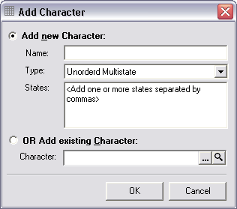
Adding New Characters to the Matrix
Characters can be added directly to the Matrix without first entering them in the Project Details window as outlined above. These can be either new characters or global characters present in the database but not yet added to this project.

Adding New Characters
To enter new characters select either the Add Character command from the Edit menu. This will open the Add Character window. Enter the character description in the upper text box, select the type of character from the list and enter states (for multistate and mixed numeric characters) in the lower text box, with individual states separated by commas. Once entered press the OK button to save this character.
The following types of characters are supported.
Unordered Multistate: Characters which contain two or more distinct states and where there is no relationship among the states.
Ordered Multistate: Characters which contain two or more distinct states and where there is a linear relationship or order among the states.
Count Numeric: An integer-based numeric character.
Measurement Numeric: A real or decimal-based numeric character.
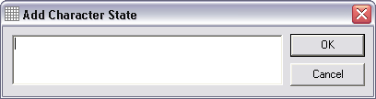
Mixed Numeric: A numeric character containing several distinct and separate values (for example maximum and minimum values or a mean and standard deviation).
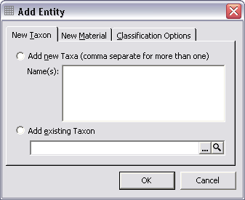
Text: A text-based character.

Selecting Existing Characters
Previously entered characters can be accessed by selecting the Add existing Character option from the lower section of the Add Character window and pressing the Character field’s ellipsis button (the first button to the right of the field). This will open the Character Explorer (see below) with a complete list of characters present in the database. The required character can then be located and the Select button used to transfer it to the Project Details window.

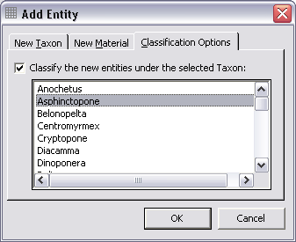
Adding New States to a Character
New states can be added to the current multistate or mixed numeric character by placing the mouse pointer over the state panel in the lower left corner of the Matrix, clicking the right mouse button and selecting the Add Character command. This will open the Add Character State window. Enter the name of the new state and click the OK button. This will add the state to the character.

Adding New Entities to the Matrix
As with characters, entities can be added directly to the Matrix without first entering them in the Project Details window. These can be either new entities or taxa or specimens present in the database but not yet added to this project.

Adding New Entities
To enter new entities select either the Add Entity command from the Edit menu. This will open the Add Entity window. To enter a taxon, click the New Taxon tab and to enter new specimens click the New Material tab. Any number of entities can be entered by listing them in the upper text box separated by commas. Entities can also be placed within other entities; that is, they can be treated hierarchically. For example, species can be placed within the genus to which they belong or specimens under a species. To enter this information open the Classification Options tab and select the parent of the entity(s) being entered. These new entities will appear under this entity in the Matrix. When all entities have been entered press the OK button to save this information.

Selecting Existing Entities
If taxa or specimens were previously entered in BioLink (for example using the Taxon Explorer or Material Rapid Data Entry) they can be accessed by selecting the Add existing Taxon or Add existing Material option on the Add Entity window and pressing the ellipsis button (the first button to the right of the field). This will open the either the Taxon Explorer or Site Explorer where the required taxon or specimen can be located. Once selected, press the Explorer’s Select button to transfer the item to the Add Entity window.

Coding Descriptions using the Matrix
Descriptions are built (or “coded”) by combining character information (states or values) and comments for each entity, one character at a time. These individual descriptions are then combined to produce text-based reports or as a data source for interactive identifications. While the details for coding varies slightly for each character type the basic approach is the same for all characters. First, highlight a cell in the upper panel of the Matrix for the entity and character to be used and then enter the details for the description in the lower panel. Details for each character type are as follows.

Ordered and Unordered Multistate Characters
These characters each have a number of states with individual states or sets of states being used to describe an entity. A list of the states for the selected character is displayed in the lower left panel of the Matrix. To code a description double-click on a state to add it to the description panel on the lower right. To add multiple states simply double-click several states one after the other. On each double-click a comma and space will be added followed by the name of the state. The comma will appear in black in the description with the state in blue. This black text indicates a “comment” while states are in blue. For a text-based description presenting information in the default format of (for example) “Wings present, absent” is undesirable. In this case this information is better presented as “Wings present or absent”. To achieve this move the cursor into the description panel, remove the comma and add “or” between the blue “present” and “absent” states. Thus the description will read “present or absent” in both blue and black text. Combining comments with states it is possible to be very expressive while still capturing the necessary state-based information needed for complex tasks such as interactive identification. In the above example it is possible to code this description as “Wings normally present but absent in some rarely encountered species which are restricted to islands”. This flexibility should meet the needs of a broad range of users.

Count and Measurement Numeric Characters
These characters do not use states but are recorded as numbers or numeric ranges. Information is entered directly in the lower Matrix panel (the state panel being absent). To enter a number simply type it in the description. To enter a range type a number followed by a hyphen or the word “to” and another number. Multiple ranges can also be entered by adding further ranges. As above, comments can be added at any point in the description.
At the bottom of the description panel is the entered information as interpreted by BioLink. This will consist of single numbers or one or more numeric ranges. This interpreted information will be used by Interactive Identification and for exporting while the description text will be used for text-based descriptions. This method is intended to give the flexibility needed to support rich text-based descriptions while also meeting the more restrictive needs of data analysis.

Mixed Numeric Characters
Mixed numeric characters are essentially a combination of state-based characters and numeric characters. For each mixed numeric character a number of “states” can be assigned, each state containing numeric information interpreted as noted above for count and measurement numeric characters. Common states for a mixed numeric character include “minimum” and “maximum” or “extreme lower number”, “number” and “extreme upper number”. Mixed numeric characters can be used to record complex numeric-based information or to allow precise capture of otherwise complex information that would require several count or measurement numeric characters.

Text Characters
Text characters are recorded as simple text with no specific interpretation. Information can be entered directly into the description panel as required.

Using Default States
There may be cases where the majority of taxa or specimens possess the same character state with only a few differing. In these cases it may be quicker to automatically assign this common state to all entities and make changes only where necessary. BioLink Morphology supports this through default character states.
To set a default character state, open the Character Explorer, locate the required character and open its Detail window. This can be done by selecting the Character Explorer command from the Morphology toolbar menu on the main BioLink toolbar, locating the required character in the Contents or Find tab and opening the character’s details using the Edit command on the Edit menu. Highlight the state to be set as the default on the General tab and press the Set Default button. The word “Default” will be displayed next to the selected state. To remove a previously set default state press the Clear Default button. Save these changes by pressing the OK or Apply button. When the Matrix is next opened this default will be used to fill descriptions using this character where data has not yet been entered (the default state will not overwrite existing data).

Inheritance and Compilation
BioLink Morphology supports hierarchical relationships among entities. For example, species can be placed within a genus or specimens within a species. There is no limit to the “depth” of the relationships specified. These relationships can be used when coding descriptions using two techniques, inheritance and compilation. Inheritance is used by children (for example, species) to gather information from their immediate parent (for example, genus) while compilation is used by parents (for example, genera) to gather information from all of their children (for example, species). Individual cells can be set to either automatically collect and refresh this information or to gather it only once.
To set inheritance or compilation, select a description cell in the upper panel of the Matrix, click the right mouse button and select one of the following commands.
To compile information, open the Compile Cell menu and select:
Compile Once to collect information and paste it into the description.
Always Compile Cell from Child Entity Cells to link the cell to its children’s information.
To inherit information, open the Inherit Cell menu and select:
Inherit Once to collect information and paste it into the description.
Always Inherit Cell from Parent Entity Cells to link the cell to its parent’s information.

With both of these methods a list of states, separated by commas, will be collected and transferred to the selected cell, any comments present being removed. If the Compile/Inherit Once commands are used the information will be copied and can be edited as required, including changing the order of states and adding comments. If the Always Compile/Inherit commands are used the information is linked rather than copied and it cannot be edited or changed manually.

Views
As discussed above under The View Explorer, views are used to develop alternate phrasings and language for characters and descriptions. Any number of views can be created and changes made to one view can update all other views in the Matrix, automatically keeping them in sync. This is an especially powerful tool, allowing the production of specialized datasets for specific purposes with minimal recoding of information.
A list of views currently in the Matrix is displayed in the lower left of the Matrix. If this window is not visible click the Views button on the centre-left of the Matrix window, below the list of entities and above the description panel. To add additional views place the cursor over the Views panel, click the right mouse button and select the Add View command. This will open the Add View window and a new view can be either selected or created as outlined above under The View Explorer.

Changing the Phrases and Language used by Views
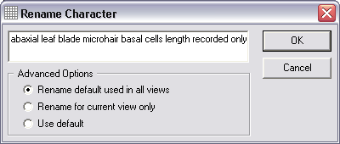
Initially all views will use the default character phrasing entered when the character or state was originally created. To change the phrasing of a character place the mouse pointer over the name of a character in the upper Matrix panel, click the right mouse button and select the Rename Character command. This will open the Rename Character window. Enter the new character name in the upper text box. To change the default name, the name used initially by all views, make sure the Rename default used in all views option is selected. To change the phrasing in the selected view only, select the Rename for current view only option. To have this view use only the default phrasing, select the Use default option. Click the OK button to save these changes. Changing the phrasing used by states is similar, but the mouse pointer is placed over a state name in the States panel and the Rename State command is used from the mouse menu.

Coding Information Using a Different View
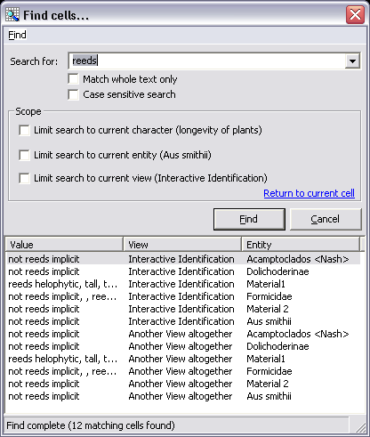
To switch to an alternate view, simply click on it in the Views panel. The Matrix will be refreshed to display information as coded in the newly selected view. By default states added to this view will be automatically added to all other views. To disable this feature, open the Matrix Preferences window using the Matrix Preferences command on the Options menu and unclick the Keep all views in sync when changes are made option. Note that comments will only be added to the active view, the other views remaining unchanged.

User-defined Traits and Resources
Each description can have user-defined traits and multimedia items associated with it. These are added by opening the appropriate panel and entering information as outlined above under Character Details. To open the Traits panel click the Traits button on the centre-left of the Matrix window, below the list of entities and above the description or views panel. To open the Resources panel click the Res. button next to the Traits button. These panels can be opened and closed as required.

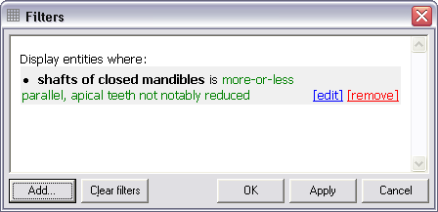
Finding and Filtering Information
BioLink Morphology provides two tools for locating information in the Matrix, Find and Filters. Find works similar to the find feature of a word processor, searching through the Matrix locating individual data items. In contrast, filters temporarily remove entities from the Matrix, reducing the information displayed. These tools are discussed below.

Finding Information in the Matrix
To use Find, select the Find command from the Edit menu. This will open the Find Cells window. Enter the text to locate in the upper text box, optionally set options to search for whole words only or to make the search case-sensitive and to limit the area of the Matrix to search (current character only, current entity only, current view only or a combination of these) and press the Find button. Cells containing the search text will be listed in the lower part of the Find Cells window. To move to the Matrix cell containing the text select an item in this lower list. The corresponding Matrix cell will automatically be selected.

Using Filters
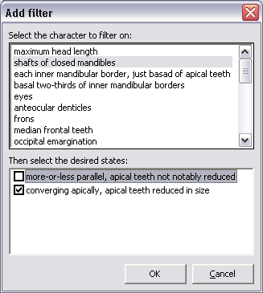
Filters are used to display only those entities which contain a given character state or set of states. When applied, those entities which do not meet the filter conditions will be hidden. This can be thought of as a mini-identification process where characters are added until only selected entities remain. To create a filter select the Filters command from the Edit menu. This will open the Filters window. To add a filter press the Add button to open the Add Filter window. This window lists characters in the upper section with the selected character’s states below (if applicable). Click the check box before a state and press the OK button to add this character state to the filter. Now press the Apply button on the Filters window to apply this filter to the Matrix. The taxa displayed will be restricted to only those with the selected character state(s). Repeat this process to add new characters as needed. To change a previously selected character press Edit to the right of the character in the Filters window. This will open the Edit Filter window with the character selected. To remove a character from the filter press Remove to the right of the character. Pressing the Apply button will update the Matrix, adding and removing taxa to meet the new criteria. To remove all filters and return to the full Matrix press the Clear Filters button followed by OK or Apply.

Changing the Look of the Matrix
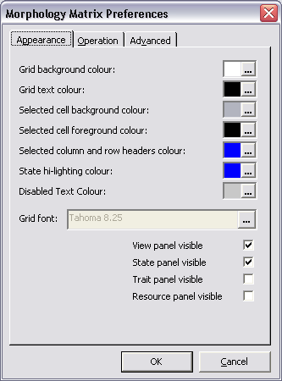
A number of options exists for changing the look of the Matrix. These are found on the Matrix Preferences window which can be accessed using the Matrix Preferences command on the Options menu. Colours can be set as well as the font type.
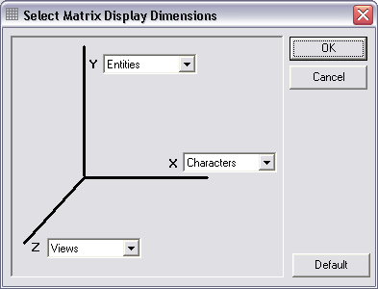
In addition, the placement of entities, characters and views can be changed. This is done with the Select Matrix Display Dimensions window, opened using the Alter Axes command on the Options menu. In essence, the Matrix can be views as a cube. By default, entities are on the Y-axis (vertically), characters on the X-axis (horizontally) and views in the Z-axis (front to back). In this configuration all entities and characters are visible but only one view can be seen at a time (the remaining views being “hidden underneath each other”). By changing the assignments of the axes, it is possible, for example, to see all views for a given character across all entities (by placing entities on the Y-axis, views on the X-axis and characters on the Z-axis). Note that in this configuration the previous Views panel (in the lower left corner of the Matrix) becomes the Character panel and is used to move between characters. This setup allows the direct comparison of the phrasings of descriptions used across views. To return to the default Matrix settings press the Default button on the Select Matrix Display Dimensions window followed by the OK button.

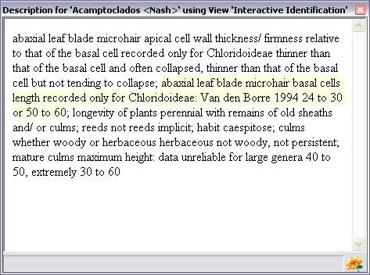
Text-based Descriptions and Diagnoses
Two text-based reports are currently available within BioLink Morphology, Description and Diagnosis. Description is used by display a paragraph-based description of an entity while Diagnosis gives a list of the fewest characters needed to identify an entity.

Descriptions
The Description window (opened using the Display Description command from the Tools menu) displays a complete description of the selected entity based on all coded characters. The description is generating by combining the name of each character followed by its description as entered in the Matrix using the currently selected view. This text can be transferred to a word processor by selecting the text (using either the mouse pointer or by pressing Ctrl-A) and using copy and paste.
The text in the Description window is tied directly to the Matrix. The currently selected Matrix description is highlighted pale yellow in the Description window and clicking on a character in the Description window will move the current cell in the Matrix to this character. Also, changes made to a description in the Matrix will immediately update the Description window. This allows the impact of changes to be seen without regenerating the complete description.

Diagnoses
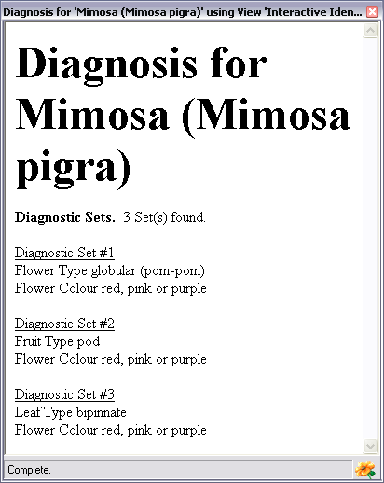
A diagnosis is the minimum set of characters needed to separate an entity from all other entities in a project. For example, if a specimen has this set of characters then it must belong to the taxon having this diagnosis. BioLink Morphology will find these sets of characters for entities coded in the Matrix.
To generate a diagnosis select an entity in the Matrix followed by the Display Diagnosis command from the Tools menu. The Diagnosis window will open containing the diagnosis for the this entity based on the currently active view.
Two special cases should be noted. First, there may be more than one set of characters which will diagnosis an entity. In this case all diagnostic sets containing the fewest number of characters will be listed (in no particular order). This will allow the most appropriate diagnosis to be selected based on the specific characters found in each set. The second case is were two (or more) entities cannot be separated. In this case these entities will be listed first, followed by diagnostic sets which separate the entity from the remaining entities. When this occurs more additional information will be needed to allow separation of these entities.

Interactive Identifications
The Interactive Identification tool is used for both interrogating data and editing and entering information. To launch this window select the Launch Interactive Identification command from the Tools menu. Interactive Identification will load data from the Matrix using the currently selected view.

The Interactive Identification window is composed of two main sections, a series of three tabs on the left and a display area on the right. The first tab contains a list of characters, the second a list of entities and the third a list of characters which have been used during an identification session. The characters are sorted by there ability to split the entities remaining in the identification into equal groups. Those characters which split the remaining entities into two equal sized sets are near the top followed by those where the split is uneven below.
When initially opened the first character in the list will be selected and its states displayed on the right side of the window. To select another state click on it in the list and its states will replace those previously displayed to the right. During an identification the state(s) which best describe the entity being identified are checked and the Submit button pressed. This information will be used to find only those entities which have been coded as having this state and the list of characters adjusted based on their separating ability. Additional characters are then selected and states scored until (hopefully) only a single entity remains. Once a single entity remains its details will replace the character details normally displayed on the right side of the window. These details are also available throughout the identification session by opening the Taxa tab and selecting one of the remaining entities. To review the characters used during an identification open the History tab. The characters and their selected states will be displayed. To remove a previously scored character and recalculate the taxa remaining click on the Remove Character link. The identification with continue without this character. To restart an identification with the complete dataset click the Restart Identification link near the upper right corner of the main window.
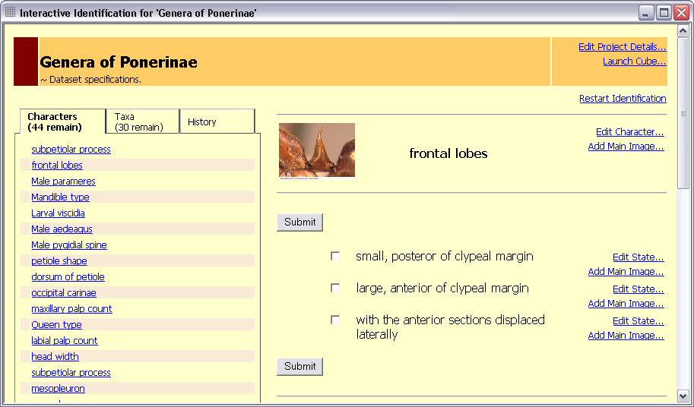
A number of data items can be added or edited directly from the Interactive Identification window. These include the following.
- Project Details: Click the Edit Project Details link in the upper right corner of the main window.
- Return to the Matrix: Click the Launch Matrix link in the upper right corner of the main window.
- Edit the selected Character: Click the Edit Character link to the right of the character name on the right side of the window. This will open the Character Detail window for the selected character.
- Add a Character Image: Click the Add Main Image link to the right of the character name on the right side of the window. This will open an Open Image File dialog window where an image to be displayed for this character can be selected.
- Edit a State: Click the Edit State link to the right of a state name listed on the right side of the window. This will open the Character State Detail window for the selected state.
- Add a State Image: Click the Add Main Image link to the right of a state name listed on the right side of the window. This will open an Open Image File dialog window where an image to be displayed for this state can be selected.
While this information can be entered directly in the appropriate Detail windows, it is often more direct to enter it while working with information during an identification session.
Views can be especially useful when combined with the Interactive Identification tool. For example, data sets intended for text-based descriptions describe entities using statements. For example “Body colour red” or “Body colour blue”. However, for interactive identification may be desirable to phrase the “character” as a question with the “states” as statements. For example, to ask “What colour is the body?” with the choices being “The body is red” and “The body is blue”. With views it is simple to prepare phrasings that meet both needs. These “datasets” are created as views of the same characters and descriptions, the views being automatically synchronized as changes are made and the most appropriate format being used for the task at hand. This flexibility meets the needs of the broadest possible range of users with minimal extra time and effort.

The Key Builder
The Key Builder is used to construct and publish dichotomous keys. These keys are an alternative to the interactive identification keys discussed above. There primary advantage is that they can be paper-based and do not require access to a computer to be used. It is also possible to hand-craft a path through the available data, something that is currently difficult with the multi-access Interactive Identification tool.

Creating a Dichotomous Key Project
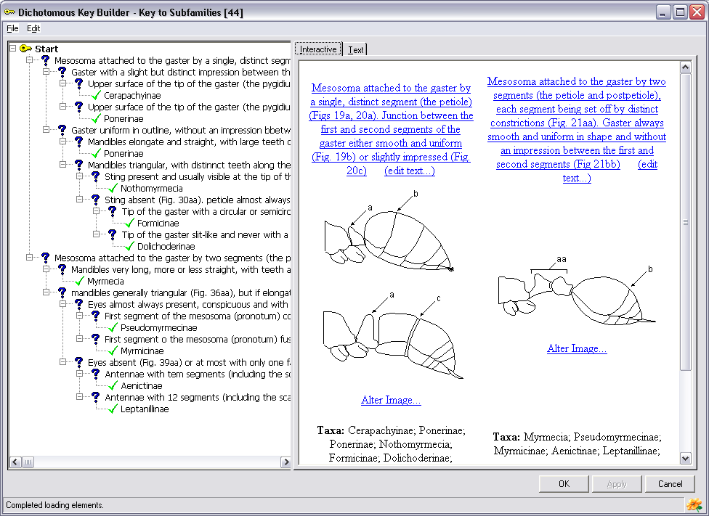
Dichotomous Key projects are created and managed using the Morphology Project Explorer. To create a new Key project first open the Morphology Explorer (as discussed above under Morphology Explorer) and select the Dichotomous Key Project command under Add on the Edit menu. Enter a name for this new project and press the Enter key. When complete press OK or Apply to save this new project. To open this project select the Edit command from the Edit menu. This will open the Dichotomous Key Builder window.

How Dichotomous Keys Work
Dichotomous keys are constructed using a series of paired, complementary questions (called a couplet, each question being called a lug) rather than by coding characters and states as is done with the Matrix. These pairs of questions are asked in a specific order, with each question leading to either another pair of questions or to the name of a taxon. Once a name is reached the identification is complete.

Problems with Paper-based Keys
Normally keys are created using a word processor with each pair of questions numbered and each question pointing to the next numbered pair of questions. There are two problems with this method. One is that if a question needs to be inserted near the top of a dichotomous key, all questions (and pointers) need to be renumbered from this point forward. As the key grows in size this becomes a tedious and error-prone task. The second problem with word-processor based keys is that they can only be reported in a single format, normally as text on paper or computer screen. To reformat a text-based key can be time consuming and it is difficult to translate this style of key into a clickable web-based key. The BioLink Key Builder gets around both of these problems by storing dichotomous keys as hierarchical lists of questions and taxa which can be formatted and presented in a number of ways as needed. Two such methods are part of the Key Builder, as a series of linked web pages and as a more traditional text-based set of numbered questions.

Building a Key with the Key Builder
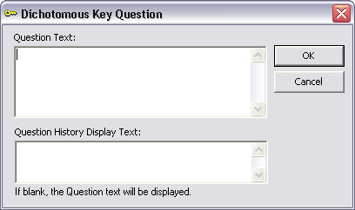
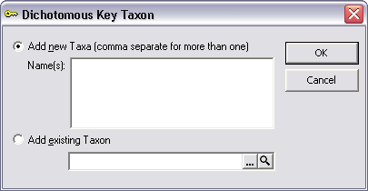
First open the Key Builder window as outlined above. Questions will be added to the left panel of the window with the key presented on the right in two formats, as an interactive set of web pages on the first tab and as static text on the second tab. The next step is to add a question. This “question” is normally presented as a statement, for example “Body colour red” with the second half of this question pair “Body colour blue”. To enter this question highlight the Start item on the left side of the Key Builder and select the Add Question command from the Edit menu. This will open the Dichotomous Key Question window. Enter a question in the upper text box and (optionally) a shorter version of this question in the lower box for use in the “Choice History” section of the web-based key. Now add the second question of this pair to the Start item. To continue building the key select one of the questions just entered and add another pair of questions or add the name of the taxon (using the Add Taxon command on the Edit menu) which will be identified if this question is selected. When the key is complete each question will lead to a taxon name, some taxa requiring only a few questions while others may require many.
During this process the key can be tested using the tabs on the right side of the window. The Text tab presents the key in a traditional manner using numbers to link the pairs of questions. The Interactive tab displays one pair of questions at a time, highlighting progress in the left panel as choices are made. This tab also allows data to be edited and entered without first moving the left panel.

Importing and Exporting Data
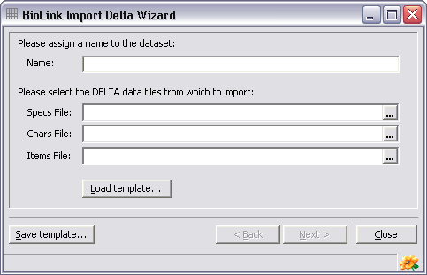
Existing information stored in DELTA and LucID formats can be automatically imported into BioLink Morphology.

Importing Data
To import information select the Import DELTA Files or Import LucID Files command from under the Morphology button on the main BioLink toolbar. These commands will open the appropriate Import Wizard window. Enter a name for the new project based on this data in the upper text box. Press the ellipsis button to the right of the lower text box and find the data file(s) to be imported. Once located and entered, press the Next button and follow the instructions to complete the import. When finished open the Project Explorer, select the newly created project and open the Matrix. Check each character and description to make sure it was imported and interpreted correctly. This information can now be edited using BioLink Morphology.

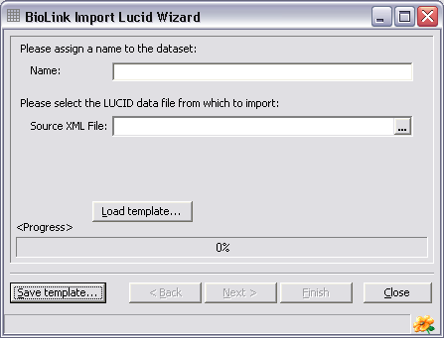
Exporting Data
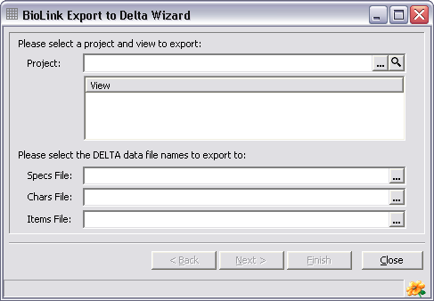
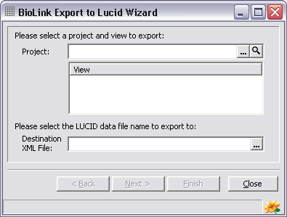
Both DELTA and LucID are powerful programs which support functionality not found within BioLink Morphology. To allow access to these features data can be exported in both DELTA and LucID formats for transfer to these programs. To export data select the Export to DELTA Files or Export to LucID Files command from under the Morphology button on the main BioLink toolbar. These commands will open the appropriate Export Wizard window. Select the name of the BioLink Morphology project and view to export, enter the name(s) of a file(s) to export to and press the Next button. Follow the instructions to complete the export. These files can then be imported into DELTA or LucID for further processing.

